**Software:**

**Frameworks Used**

1. Pandas: For data analysis and manipulation, Pandas is a Python package. In this case, it reads the specified CSV file. Pandas offers dataframes, which are comparable to database tables, and other data structures and functions that make working with structured data simple[1].
2. Numpy: Another Python module, Numpy focuses mostly on mathematical and numerical operations. In this case, it is utilized to vectorize the data, enabling quick and effective operations on arrays and matrices. Especially when working with big datasets, this is helpful[2].
3. sklearn, or scikit-learn: Python has a machine learning library called Scikit-learn. It is utilized in your project to train a supervised machine learning model called a Support Vector Machine (SVM). Regression and classification tasks are handled by SVM. Furthermore, the accuracy of the trained SVM model is assessed using the metrics module of scikit-learn[3].Django: Django, is a high-level Python web framework. In this project, it's used to host and run the SVM model. It also handles input from the IoT device and it receives data from the device, passes it to the SVM model for processing, and returns the results.
4. React: React, is a JavaScript library for building user interfaces. In this project, it's used to display the count and amount of plastics that have been segregated so far. React's component-based architecture is helpful for creating interactive and dynamic displays, allowing users to see real-time updates of the segregated plastics.

**Methodology:**

1. Our Machine Learning Model : The SVM model's ability to handle high-dimensional data and nonlinear boundaries makes it a suitable candidate for this challenging classification task.
2. Dataset Preprocessing: The dataset, comprising 31 samples, underwent preprocessing using the StandardScaler[4] to standardize the distribution of features. Categorical data representing plastic types were encoded as numerical labels: 0 for PP, 1 for HDPE, and 2 for PET.

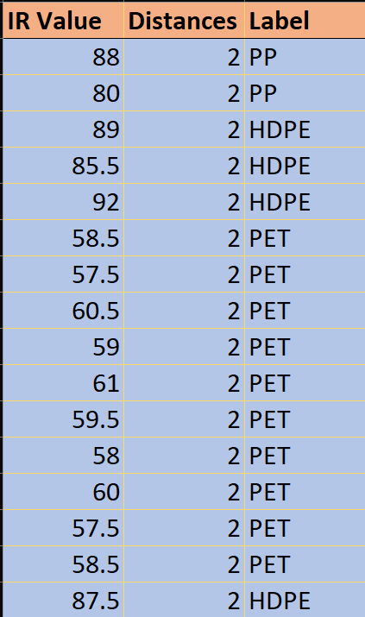

1. Support Vector Machine Model: We used a Non-Linear Support Vector Machine (SVM) model as the data was observed to follow a non-linear trend. The SVM model was trained using default kernel parameters, with gamma set to "auto [5], enabling effective control over the classification accuracy and decision boundary optimization.
2. Cloud-Computing : The Implementation of the SVM model is done through the use of cloud computing.
3. The inputs are given as live data through open web socket connection between the IoT device and the server.
4. The Cloud server feeds the input data into the SVM model built and the output is acquired.
5. This out put is sent to two WebSockets – one back to the IoT device. The other to the web client which is keeping a track of the segregated plastics
6. Web Client : A web client is built which is used to keep track of the plastics segregated so far. This dashboard acts as a data visualization tool to better understand the use and disposals of plastics.

**Result :**

1. Accuracy and Performance: The trained SVM model exhibited an impressive 96% accuracy in differentiating between various plastic types based on their infrared (IR) reflectance and distance features. This high accuracy underscores the model's efficacy in addressing the complexities of multi-class plastic classification tasks.
2. Comparison with Market Standards: Compared to existing methods in the market, the proposed SVM model showcased superior accuracy and robustness, outperforming traditional classification techniques and demonstrating its potential to revolutionize current plastic sorting and recycling technologies.
3. Potential for Improvement: Although the SVM model achieved exceptional accuracy, further research could focus on optimizing kernel parameters, exploring different feature engineering techniques, and incorporating additional environmental factors to enhance the model's predictive capabilities. Additionally, the integration of advanced deep learning approaches could offer improved plastic classification and sorting efficiency.
4. Integration of IoT, Server, and Web Application Model: The IoT system was deployed to collect real-time data on plastic distribution, transmitting the data to a dedicated server. The server, equipped with data processing capabilities, received and processed the incoming data, facilitating seamless integration with the SVM model for accurate plastic classification. The web application provided an intuitive interface for users to monitor and analyse the real-time distribution of various plastic types, fostering informed decision-making and proactive environmental interventions.

The integrated approach enabled real-time monitoring and analysis of plastic distribution, offering valuable insights into the patterns and trends of plastic usage and disposal. The seamless synergy between the SVM model and the IoT, server, and web application framework demonstrated the potential for a comprehensive and proactive approach to waste management, promoting sustainable practices and environmental conservation efforts.

[1] - Mckinney, Wes. (2011). pandas: a Foundational Python Library for Data Analysis and Statistics. Python High Performance Science Computer.

[2] - Harris, C.R., Millman, K.J., van der Walt, S.J. et al. Array programming with NumPy. Nature 585, 357–362 (2020).

[3] - edregosa, F., Varoquaux, Ga"el, Gramfort, A., Michel, V., Thirion, B., Grisel, O., … others. (2011). Scikit-learn: Machine learning in Python. *Journal of Machine Learning Research*, *12*(Oct), 2825–2830.

[4] - C. Nair and D. Ng, "On the Scalar Gaussian Interference Channel," 2018 Information Theory and Applications Workshop (ITA), San Diego, CA, USA, 2018, pp. 1-5, doi: 10.1109/ITA.2018.8503234.

[5] - Shadeed, Intisar & Alwan, Jwan & Abd, Dhafar. (2020). The effect of gamma value on support vector machine performance with different kernels. International Journal of Electrical and Computer Engineering (IJECE). 10. 5497. 10.11591/ijece.v10i5.pp5497-5506.